**CHAPTER 2**

**Review of Relative System**

This diagram will show the software product that are related to the functions and capabilities of the proposed system.

|  |  |  |  |  |  |  |
| --- | --- | --- | --- | --- | --- | --- |
| **NAME** | **DEVELOPER** | **WEBSITE** | **LATEST RELEASE** | | **FEATURE 1** | **FEATURE 2** |
| *Version* | *Date* |
| Student Information System | **Engr. Lyndon R. Bermoy** | sourcecodester.com | PHP | April 26, 2014 | Student Management  Student Information (Add, Edit, Delete) | Login  Logout  Update Record  Registration |
| School Management System | **Turinawe vian** | sourcecodester.com | PHP | August 4, 2015 | Manage School Fees,  Manage Staff and Salary,  Manage Expenses,  Manage Subject (add, edit and delete),  Manage Users  Admin Settings | Accounting reports,  Student Registration (add, edit, delete, view)  Reports of student |
| Inventory System | Muhammad ahsanriaz | sourcecodester.com | PHP | August 9, 2014 | Manage Sale list (Add Sales, View, Edit, Delete)  Manage Customer  Manage Purchase,  Manage Supplier,  Manage Stocks  Manage Products  Manage Payments and outstanding | Reports of Sales stock  Capabilities of Update or Edit details and add Picture  Print  Statistic and Stock information  Search |
| Schoology: Learning Management System(LMS) | Joseph DiMauro | Schoology.com | PHP | November 2016 | Advanced analytics  Align content to Common Core and State Standards,  Automate grading system and performance-based analytics  Automatically updating online grading system  Centralize online educational activity  Collaboration-based interface  Create custom applications  Curriculum management  Student information systems integration  Transform classroom courses into a 1:1  Webpage creation tools | Calendars, messaging, and personal/shared content  Global community for sharing resources  Open-access integration platform  Schoology mobile apps  Instructor tools for course creation and management  Resource sharing center and instructors |
| TalentLms | Sakis Valavanis | Talentlms.com | PHP | January 4, 2016 | Course Authoring  Custom Branding  Custom Fields  Admin Reporting  Course Catalog  Custom Reporting  Data Import/Export  Defined User Roles  Display Transcripts  Grading  Individual Plans  Mobile Access  Web Conference  Multi-organization Structure (Branches)  Certification Management | Exam Engine  Registration Management  File Exchange  Testing  Training Metrics  ILT Support  Custom Homepage  Course Marketplace  eCommerce  Automated Actions  Notification |
| Edmodo | Nic Borg, Jeff O'Hara, Crystal Hutte | Edmodo.com | PHP | September 13, 2015 | Accelerate learning goals  Activate your free admin account  Award badges to individual students  Build a network of communities  Create polls for students | Measure student progress  Network that connects students, administrators  Online classroom discussions  Personalize with apps |

**USE CASE DIAGRAM**

Student Information Record System

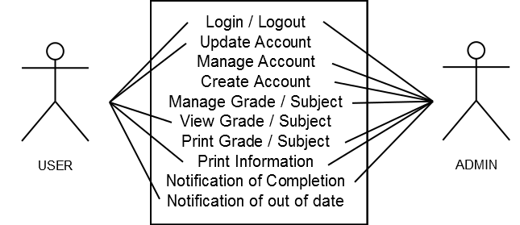

*Figure. 1 Use Case Diagram*

**Activity Diagram**

The following diagram shows the processes of the proposed “Online Student Information System”.

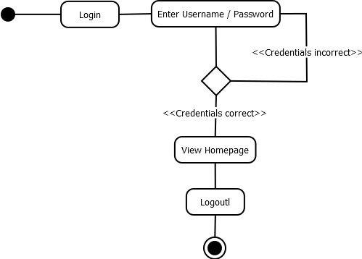

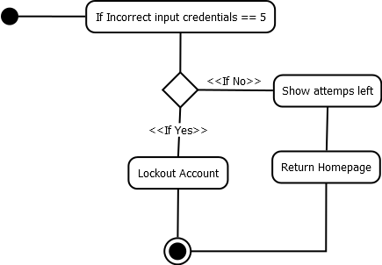 *Figure. 2 Activity Diagram for Login*

*Figure. 2.1 Activity Diagram for Security login*

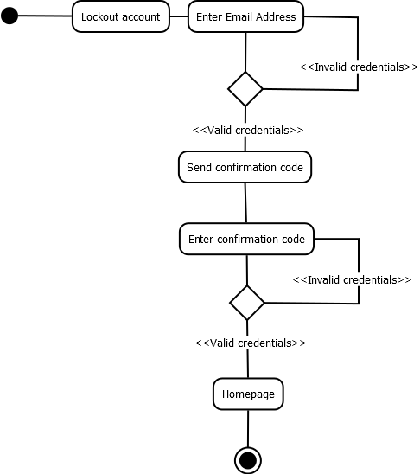

*Figure. 2.2 Activity Diagram for Lockout Account*

This following Diagram shows the student processes for homepage, the homepage

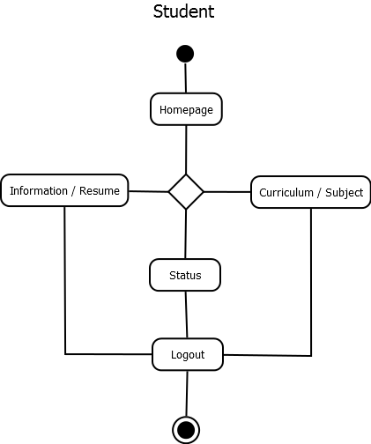

*Figure. 2.3 Activity Diagram for Student Homepage*

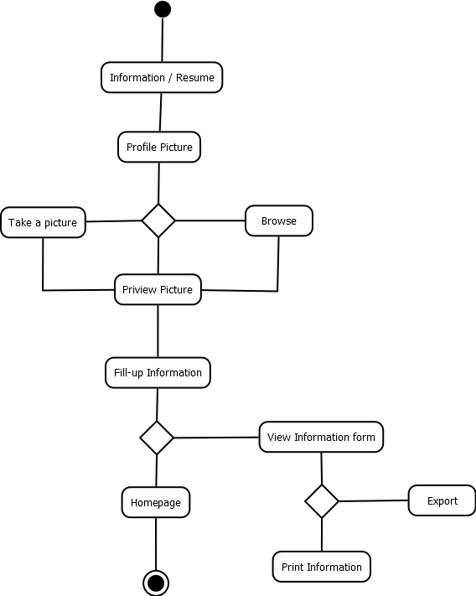

*Figure. 2.4 Activity Diagram for Student Information*

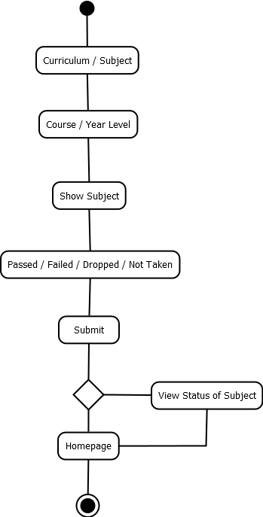

*Figure. 2.4 Activity Diagram for Student Curriculum and Subject*

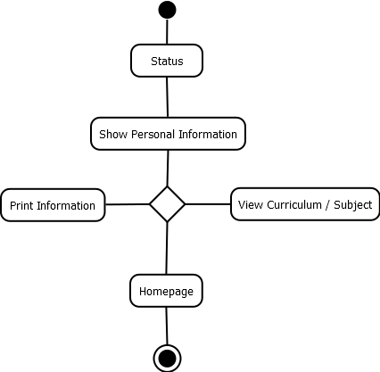

*Figure. 2.4 Activity Diagram for Student Status*

This following Diagram shows the administration processes for homepage, the homepage